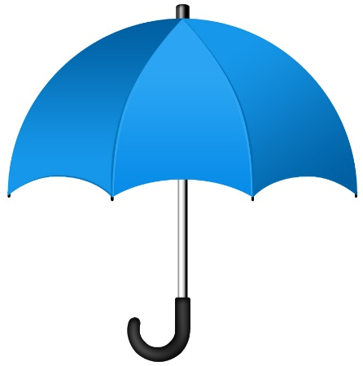
Disney Love Songs
Match the Disney movie with the unforgettable love song….Come on, you know you want to hum along!

_____ Sleeping Beauty
_____ Cinderella
_____ Snow White
_____ The Lion King
_____ Enchanted
_____ Aladdin
_____ Tarzan
_____ Hercules
_____ Beauty and the Beast
_____ Pete’s Dragon
_____ UP
_____ The Little Mermaid

- True Love’s Kiss
- Can You Feel The Love Tonight
- Candle on the Water
- A Whole New World
- Married Life
- Kiss the Girl
- Once Upon A Dream
- You’ll Be In My Heart
- I Won’t Say I’m In Love
- So This Is Love
- Someday My Prince Will Come
- Something There

